

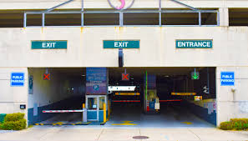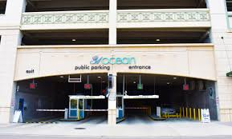

**Ambassador/ Enforcement Officer/Cashier**

Shows a commitment to quality service by promoting local business, public safety and quality of life by patrolling assigned beat to monitor, regulate, and control parking. Processes day-to-day cash and credit transactions using a point of sale system. Advocates good will for the City of Virginia Beach by providing excellent customer service to residents and guests. Demonstrates a knowledge of parking ordinances, parking options and rates, and Oceanfront events and amenities to assist guests and residents. Creates a positive image of the City of Virginia Beach by demonstrating a high degree of professionalism. Is empathetic and composed when resolving minor customer service issues.

• **Outstanding communication skills**

**• Excellent customer service skills**

**• Capable of using current technology**

**• Ability to communicate via e-mail**

**• Clean driving record**

**• Capable of sitting, standing and walking for extended periods of time**

**• Able to work in all weather conditions**

**• Has the ability to be flexible with schedule**

**• Must be able to work holidays and weekends**

**• Must be able to work hours in excess of normally scheduled hours**

* **Must be at least 18yrs old.**

**For consideration please send your resume to Deborah Bailey at** [**dalexander@vcwhamptonroads.org**](mailto:dalexander@vcwhamptonroads.org)

**$14/hour**

**Full-time**

**Seasonal**

LOOKING FOR A FUN, SEASONAL JOB WITH A POTENTIAL CAREER IN PARKING?