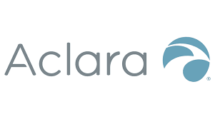

***https://www.eventbrite.com/x/aclara-virtual-hiring-event-tickets-128549245253***

[**CLICK HERE TO REGISTER ON EVENTBRITE**](https://www.eventbrite.com/x/aclara-virtual-hiring-event-tickets-128549245253)

**Join Us! Tuesday, December 1st, 2020**

**12:00PM-2:00 PM**

***To connect to the event, you will need to be able to connect to the ZOOM app on your Phone, iPad, Tablet, Laptop or Desktop Computer***

*Aclara is looking for locals to join our full-time meter installation team. The Meter Installers are responsible for safely and efficiently replacing electric and/or gas meters on residential or commercial property.*

***No Experience Required – Training Provided***

***Virginia Beach, VA & Surrounding Areas***

***$17.00-$20.00/hour + Daily Install Incentives***

**Virtual Hiring Event**

**Position Available: Meter Installers**

**Requirements:**

* Valid Driver’s License.

**Physical Demand:**

**•** Physical ability to work in an outdoor environment, including, but not limited to: Walking, climbing, and stooping for up to 10 hours per day in all types of weather conditions.

**Preferred Qualifications:**

**•** Previous working experience in the construction field (Electrical, Natural Gas Meters, Telecom, Solar, Cable Field Techs or HVAC).

**To attend the event, you must register with the VAWC:**

[**Click here.**](https://www.vawc.virginia.gov/vosnet/loginintro.aspx?blnStartHere=True&plang=E)