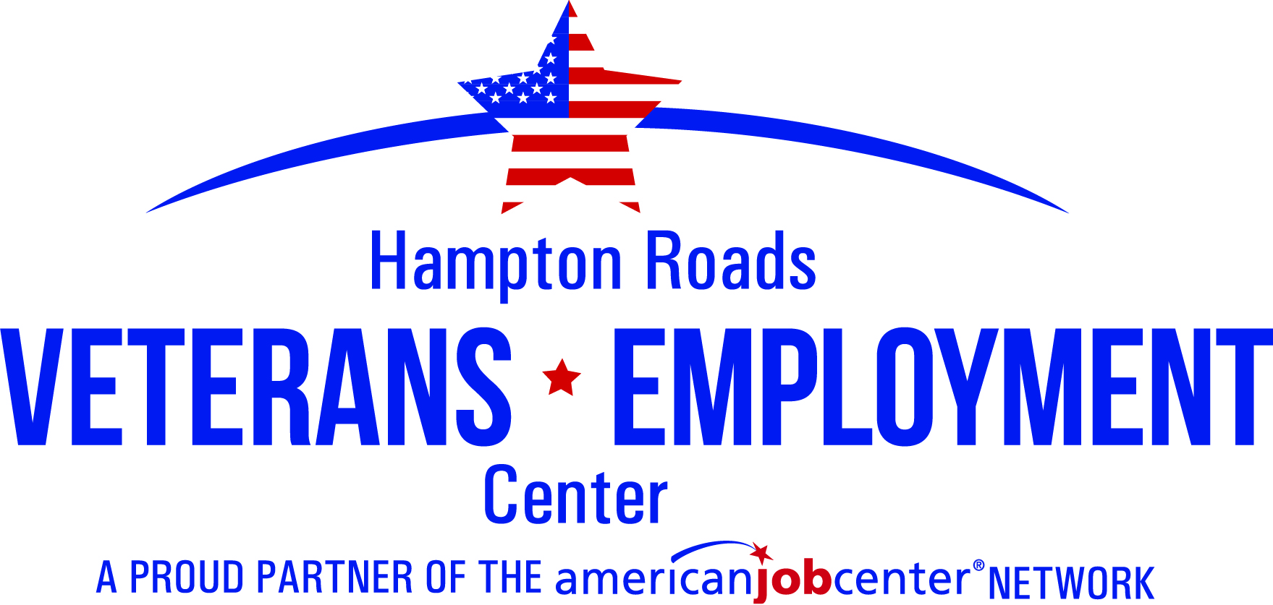
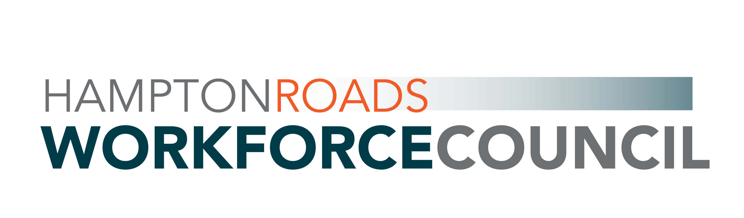
Mon | Tue | Wed | Thu | Fri
4  VCW Marketing Your Resume  1:30 – 3:00 | 5 | 6  HRVEC Marketing Your Resume  (Veteran Employment Team)  9:30 – 11:00 | 7  VCW Interview Techniques  10:30 -12:00 | 8  HRVEC Interview Techniques  ( Veteran Employment Team)  1:30 - 3:00
11  VCW Marketing Your Resume  1:30 – 3:00 | 12 | 13  VCW Job Search Strategies  10:30 – 12:00 | 14  VCW Interview Techniques  10:30 -12:00 | 15  HRVEC Marketing Your Resume  (Veteran Employment Team)  1:30 – 3:00
18  VCW Marketing Your Resume  1:30 – 3:00 | 19 | 20  HRVEC Interview Techniques  (Veteran Employment Team)  9:30 -11:00  VCW Job Search Strategies  10:30 – 12:00 | 21  VCW Interview Techniques  10:30 -12:00 | 22  HRVEC  Federal Employment  (Veteran Employment Team)  1:30 – 3:00
25 Closed  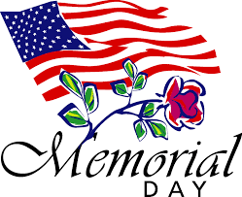 | 26 | 27  HRVEC Marketing Your Resume  (Veteran Employment Team)  9:30 – 11:00  VCW Job Search Strategies  10:30 – 12:00 | 28  VCW Interview Techniques  10:30 -12:00 | 29  HRVEC Interview Techniques  (Veteran Employment Team)  1:30 - 3:00

Funded by the U.S. Department of Labor, Workforce Innovation and Opportunity Act. Virginia Career Works Norfolk Center is an Equal Opportunity Employer/Program

LINKS TO EVENTBRITE

VCW MARKETING YOUR RESUME (MULTIPLE EVENTS)
https://www.eventbrite.com/e/virginia-career-works-hampton-roads-virtual-resume-workshop-tickets-104145792870

VCW INTERVIEW TECHNIQUES (MULTIPLE EVENTS)
https://www.eventbrite.com/e/virginia-career-works-interview-techniques-workshop-tickets-104132593390

VCW JOB SEARCH STRATEGIES (MULTIPLE EVENTS)
https://www.eventbrite.com/e/virginia-career-works-job-search-strategies-workshop-tickets-104143600312

HRVEC MARKETING YOUR RESUME(MAY 6)
https://www.eventbrite.com/e/hampton-roads-veterans-employment-center-marketing-your-resume-tickets-104168653246

HRVEC MARKETING YOUR RESUME (MAY15)
https://www.eventbrite.com/e/hampton-roads-veterans-employment-center-marketing-your-resume-tickets-104169232980

HRVEC MARKETING YOUR RESUME (MAY 27)
https://www.eventbrite.com/e/hampton-roads-veterans-employment-center-marketing-your-resume-tickets-104168899984

HRVEC INTERVIEW TECHNIQUES (MAY 8)
https://www.eventbrite.com/e/hampton-roads-veterans-employment-center-interview-techniques-tickets-104169305196

HRVEC INTERVIEW TECHNIQUES (MAY 20)
https://www.eventbrite.com/e/hampton-roads-veterans-employment-center-interview-techniques-tickets-104169385436

HRVEC INTERVIEW TECHNIQUES (MAY 29)
https://www.eventbrite.com/e/hampton-roads-veterans-employment-center-interview-techniques-tickets-104169582024

HRVEC FEDERAL EMPLOYMENT
https://www.eventbrite.com/e/hampto-roads-veterans-employment-center-federal-employment-tickets-104169626156

Funded by the U.S. Department of Labor, Workforce Innovation and Opportunity Act. Virginia Career Works Norfolk Center is an Equal Opportunity Employer/Program

