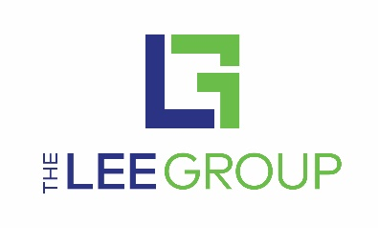

Are you into cool tools? Looking for dependable, long-term work? Here’s an opportunity to be part of building one of America’s number one selling brands! *

Reliance Staffing and The Lee Group, in partnership with STIHL Inc. and Virginia Career Works Norfolk Center, a part of Hampton Roads Workforce Council, are seeking highly motivated and dedicated individuals to support STIHL’s manufacturing facility in Virginia Beach. Reliance Staffing and The Lee Group currently have openings available in manufacturing departments at STIHL across multiple shifts.

If you are looking for dependable, long-term work with an opportunity for a great career, join us for an interview!

Thursday, October 1st, 12:00 pm to 6:00 pm
Wednesday, October 7, 12:00 pm to 6:00 pm
Thursday, October 8th, 8:00 am to 5:00 pm
at
Virginia Career Works- Norfolk Center
861 Glenrock Rd. Suite 114 Norfolk, VA 23502

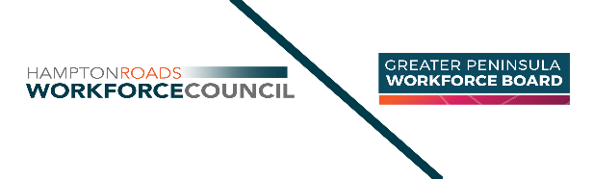
Manufacturing positions available ($13/hr. to $15/hr.)
AN EQUAL OPPORTUNITY EMPLOYER/PROGRAM Auxiliary aids & services are available upon request to individuals with disabilities. TDD: VA Relay Center: 711 or 800-828-1120. This workforce product was funded by a grant awarded by the U.S. Department of Labor’s Employment & Training Administration. The product was created by the recipient & does not necessarily reflect the official position of the U.S. Department of Labor. The Department of Defense & the Service Branches do not endorse any company, school, sponsor, or their products, or services.
All applicants are required to wear a mask, maintain social distancing and will go through a CDC questionnaire prior to interviews.

Allow one hour to complete your application, a skills assessment and interview conducted by either Reliance Staffing or The Lee Group.

Bring your resume or list of previous employment.

The physical requirements of these manufacturing jobs require constant repetitive motions, standing, reaching, bending, stretching, manual dexterity and visual acuity. Please consider your ability to perform constant repetitive motion before applying for these opportunities.

Applicants selected for positions with Reliance or The Lee Group must complete a pre-employment screening, including drug and background checks.

If you are not able to attend the fair but are interested in an exciting career, contact either Reliance Staffing or The Lee Group. Visit www.reliancestaffing.com or www.theleegroup.com for an interview.

